Sprint 3

|  |  |
| --- | --- |
| **DATE** | **17 november 2022** |
| **TEAM ID** | **PNT2022TMID45918** |
| **PROJECT NAME** | **IOT BASED SMART CROP PROTECTION FOR**  **AGRICULTURE** |
| **MAXIMUM MARK** | **20 MARKS** |

STEP1: Simulated program to get the random values.

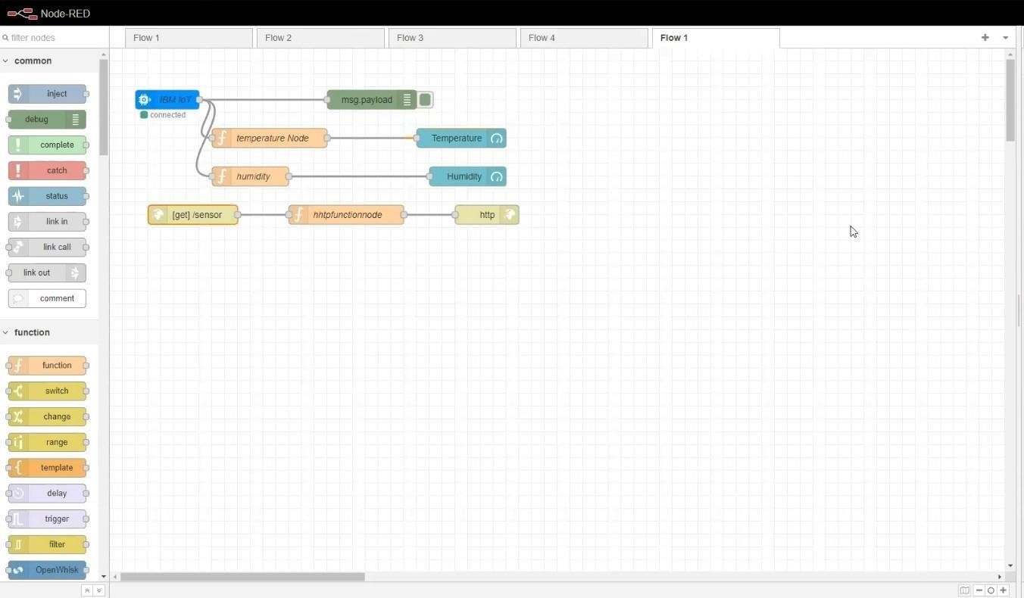

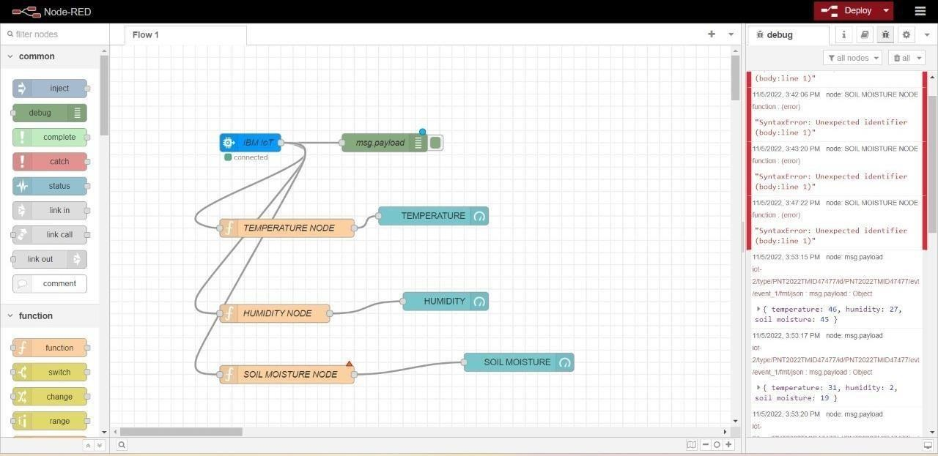

STEP2: Generate debug message from IBM Watson IoT Platform and connect the nodes.

STEP3: Generate the some output from recent events.

